

**TAYYABA REHMAN**

**49690**

**LAB 5**

**CODE:**

create database lab;

use lab;

create table Users (

User_ID INT PRIMARY KEY,

User_NAME VARCHAR(50) NOT NULL,

User_Email VARCHAR(30)

);

INSERT INTO Users

( User_ID,User_NAME,User_Email)

Value

(1,'John Doe','john@gmail.com'),

(2,'Jane Smith','jane@gmail.com'),

(3,'James Brown','james@gmail.com'),

(4,'Emily Jones','emily@gmail.com'),

(5,'Michael Taylor','sara@gmail.com'),

(6,'David Martinez','david@gmail.com'),

(7,'Laura Garcia','laura@gmail.com'),

(8,'Ayesha Asad','ayesha@gmail.com'),

(9,'Sophia Haris','sophia@gmail.com'),

(10,'James Walker','james@gmail.com'),

(11,'Olivia Young','olivia@gmail.com'),

(12,'William King','william@gmail.com'),

(13,'Taylor David','taylor@gmail.com'),

(14,'Haris James','haris@gmail.com'),

(15,'Garcia King','garcia@gmail.com');

SELECT * FROM Users;

SELECT * FROM Users WHERE User_NAME LIKE 'A%';

SELECT * FROM Users

WHERE User_Email LIKE '%@example.com';

create table Products (

Product_ID INT PRIMARY KEY,

Product_NAME VARCHAR(50) NOT NULL,

Product_Price decimal

);

INSERT INTO Products

( Product_ID,Product_NAME,Product_Price)

Value

(1,'Shampoo',800),

(2,'Earphones',550),

(3,'Noodles',45),

(4,'MilkPak',450),

(5,'Everyday',1500),

(6,'Phone',50),

(7,'Tresme',1000),

(8,'Dairy Milk',50),

(9,'Toffee',10),

(10,'Laptop',100000),

(11,'Hp',150000),

(12,'Towel',3000),

(13,'Cycle',5000),

(14,'glasses',900),

(15,'Perfume',40000);

SELECT * FROM Products

WHERE Product_Price BETWEEN 10 AND 50

AND (Product_NAME LIKE '%phone%' OR Product_NAME LIKE '%tablet%');

SELECT MIN(Product_Price) AS min_price, MAX(Product_Price) AS max_price FROM Products;

SELECT * FROM Products

WHERE Product_ID IN (1, 5, 9);

SELECT DISTINCT Product_NAME FROM Products;

Create Table Orders

(

Order_ID int Primary Key,

User_ID INT Not NULL,

User_Name VARCHAR(30),

Order_Status Varchar(50),

Product_Name VARCHAR(30),

Product_Price decimal,

Order_Date date

);

Drop table Orders;

INSERT INTO Orders

(Order_ID,User_ID,User_Name,Order_Status,Product_Name,Product_Price,Order_Date)

value

(11,1,'John Doe','Ordered','Shampoo',800,'2024-01-01'),

(22,2,'Jane Smith','Ordered','MilkPak',450,'2024-01-15'),

(33,3,'James Brown','Ordered','Everyday',1500,'2024-01-22'),

(44,4,'Emily Jones','Ordered','glasses',900,'2024-01-25'),

(55,5,'Michael Taylor','Ordered','Milkpak',450,'2024-03-22'),

(66,6,'David Martinez','Ordered','Laptop',100000,'2024-09-01'),

(77,11,'Olivia Young','Ordered','Noodles',45,'2024-12-30'),

(88,3,'James Brown','Ordered','Tresme',1000,'2024-02-01'),

(99,2,'Jane Smith','Ordered','Shampoo',800,'2024-01-16'),

(1010,13,'Taylor David','Ordered','Earphones',550,'2024-05-23'),

(1111,11,'Olivia Young','Ordered','Everyday',1500,'2024-12-30'),

(1212,14,'Haris James','Ordered','Toffee',10,'2024-04-27'),

(1313,10,'James Walker','Ordered','Perfume',40000,'2024-06-11'),

(1414,7,'Laura Garcia','Ordered','Phone',50000,'2024-01-18');

SELECT * FROM Orders

WHERE User_ID = 3

ORDER BY Order_Date DESC;

SELECT * FROM Orders

ORDER BY Order_Date ASC

LIMIT 10;

SELECT COUNT(*) AS total_orders,

AVG(Product_Price) AS avg_price,

SUM(Product_Price) AS total_price

FROM Orders;

SELECT * FROM Orders

WHERE Order_Date BETWEEN '2024-01-01' AND '2024-02-01';

SELECT SUM(Product_Price) AS order_total FROM Orders;

**TABLES:**

**USERS:**

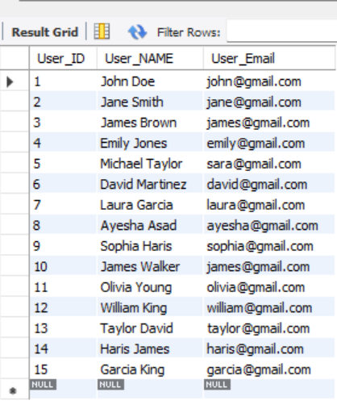

**PRODUCTS:**

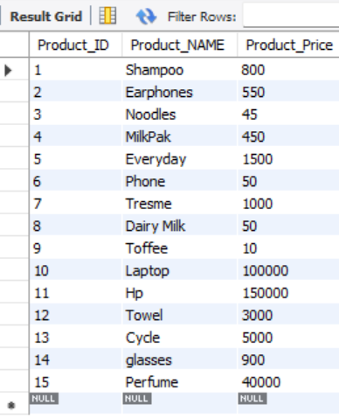

**ORDERS:**

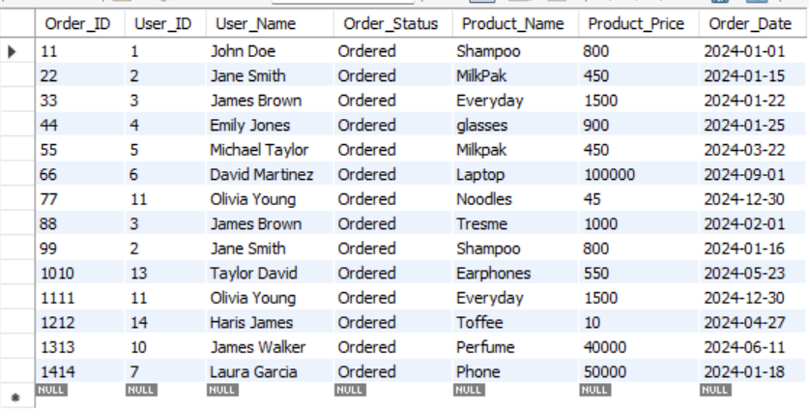

**TASKS:**

**TASK 1:** Retrieve all columns from the "Users" table.

**CODE:**

SELECT * FROM Users;

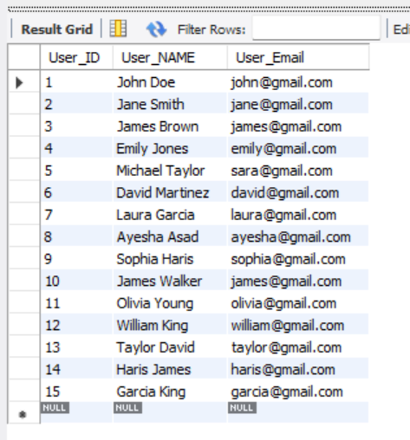

**TASK 2:** Retrieve all users whose usernames start with the letter 'A'.

**CODE:**

SELECT * FROM Users WHERE User_NAME LIKE 'A%';

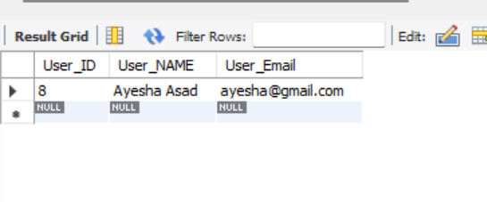

**TASK 3:** Retrieve all products priced between $10 and $50 and whose names contain 'phone' or 'tablet'.

**CODE:**

SELECT * FROM Products

WHERE Product_Price BETWEEN 10 AND 50

AND (Product_NAME LIKE '%phone%' OR Product_NAME LIKE '%tablet%');

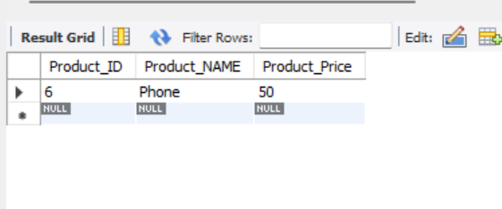

**TASK 4:** Retrieve all orders placed by user_id 3 ordered by their creation date in descending order.

**CODE:**

SELECT * FROM Orders

WHERE User_ID = 3

ORDER BY Order_Date DESC;

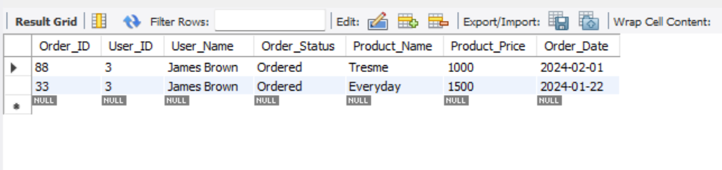

**TASK 5:** Find the minimum and maximum price of products in the "Products" table.

**CODE:**

SELECT MIN(Product_Price) AS min_price, MAX(Product_Price) AS max_price FROM Products;

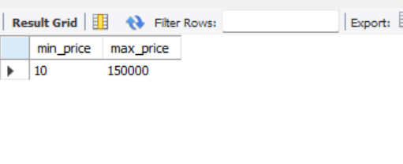

**TASK 6:** Retrieve the first 10 orders placed.

**CODE:**

SELECT * FROM Orders

ORDER BY Order_Date ASC

LIMIT 10;

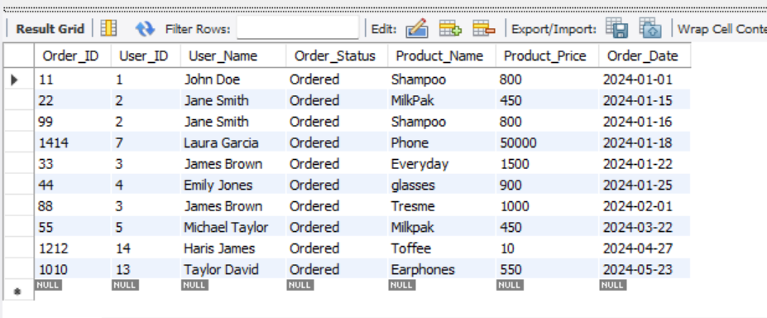

**TASK 7:** Count the total number of orders placed, calculate the average price of products, and sum up the total price of all orders.

**CODE:**

SELECT COUNT(*) AS total_orders,

AVG(Product_Price) AS avg_price,

SUM(Product_Price) AS total_price

FROM Orders;

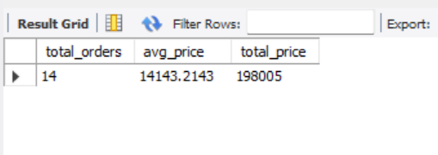

**TASK 8:** Retrieve all users whose emails end with '@example.com'.

**CODE:**

SELECT * FROM Users

WHERE User_Email LIKE '%@example.com';

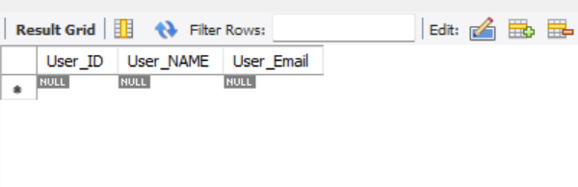

**TASK 9:** Retrieve all products with IDs 1, 5, and 9.

**CODE:**

SELECT * FROM Products

WHERE Product_ID IN (1, 5, 9);

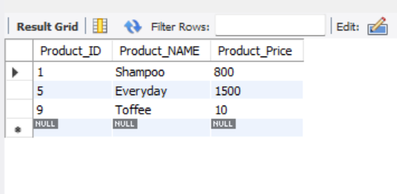

**TASK 10**: Retrieve all orders placed between January 1, 2024, and February 1, 2024.

**CODE:**

SELECT * FROM Orders

WHERE Order_Date BETWEEN '2024-01-01' AND '2024-02-01';

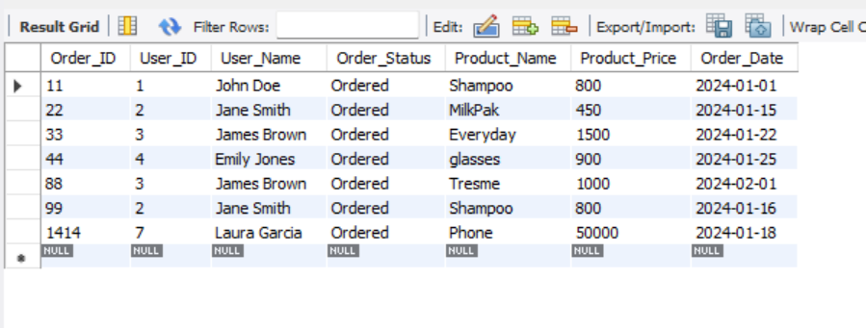

**TASK 11:** Retrieve the total price of orders, aliased as "order_total".

**CODE:**

SELECT SUM(Product_Price) AS order_total FROM Orders;

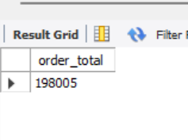

**TASK 12:** Retrieve unique product names from the "Products" table.

**CODE:**SELECT DISTINCT Product_NAME FROM Products;

